**LAB TASK**

**Name: M.Saad Badar**

**RegNo: Sp24-BSE-082**

**Course: Object Oriented Programming**

**Lab Task: 03**

**Output Window 1**

When the code compiles and Run it shows this window

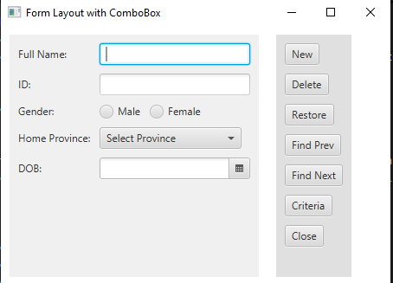

* When Data is filled and New is pressed it saves it in The Data.txt File
* If any Field is not filled it Shows alert using Alert Built in class.

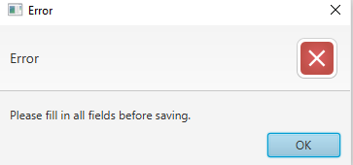

* When Complete data is filled and new is pressed it saves it in File of Data.txt as shown below

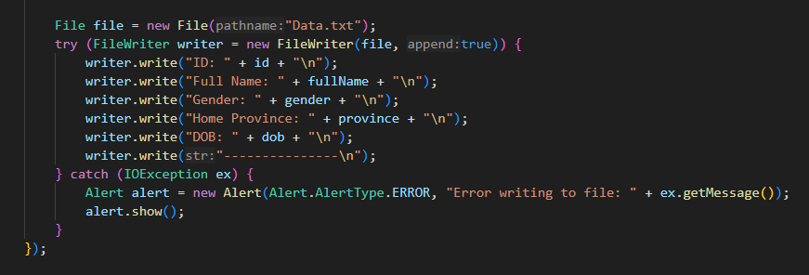

* First it saves the ID so that while displaying we can use LOOP

**Output Window 2**

* When all fields are Filled and saved and User Press “Find Prev”
* A New stage is created in setONAction.
* The second output is as shown below

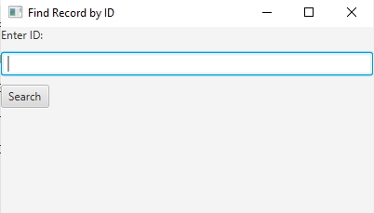

* When user Enter the saved ID, it checks it using equals and then then use stringbuilder and append the next four lines as the ID is saved first and all other data will be in next four lines , then it displays it using that string builder.

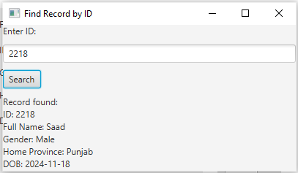

**Search Functionality**

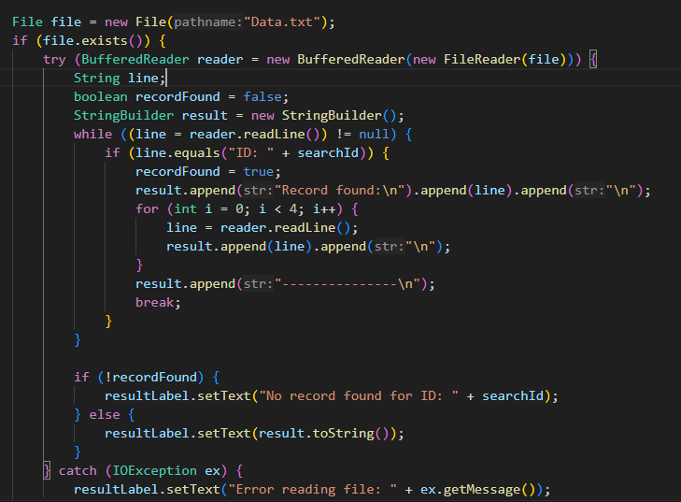

* Using BufferedReader in try block to be auto Closeable .
* I use String Builder to collect data and display by calling it.
* When ID matches using equals it appends Record Found and append the line which matched
* Then ititiates a loop which append next four lines and save it
* Then its toString is called which Displays it .